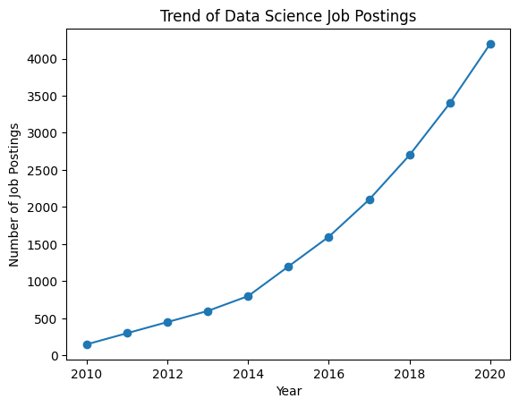
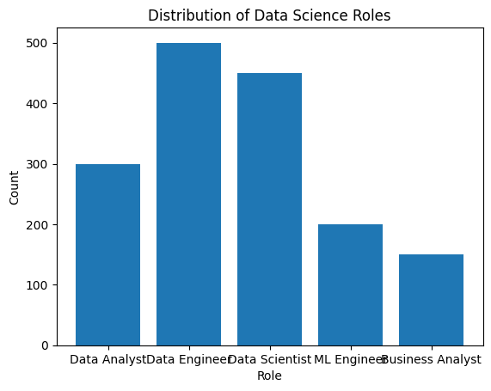
Structured Date:
ID Name Age
0 1 Alice 25
1 2 Bob 30
2 3 Charlie 35
Unstructured Data:
This is an example of unstructured data. It can be a piece of text, an image, or a video file.
Semi-structured Data:
{'ID': 1, 'Name': 'Alice', 'Attributes': {'Height': 165, 'Weight': 68}}
Original Data: b'Rajalakshmi Engineering College.'
Encrypted Data: b'gAAAAABqiczFwECTuInq8NcbTLJa2ERPKnjOfFcPYI0tJadRGxBS3Fnvq_BR_YyWaEFDDepNKnLL4IuZT2-d4q0wmVXaEvfBlRR4zHcsqZxp9aySiin_dj0A5N4ZL98X5gg7lx5A3u8G'
Decrypted Data: b'Rajalakshmi Engineering College.'

